Global meeting on WASH in health care facilities:

from resolution to revolution

Social Media Kit: #R2RWASHinHCF

Introduction
Use these sample messages and graphics to show your support for WASH in Health Care Facilities on social media during the week of the Zambia meeting, September 9-11 2019.

We welcome individuals to post their own messages and also urge partners to activate their communications teams to support using the sample messages and graphics provided.

Twitter messages and # suggestions (can be modified)

Hashtags
Suggested hashtag for the week of the meeting (to make it easy to see all unique tweets associated with the meeting and to have everyone join in the conversation around this special occasion):
#R2RWASHinHCF & the commonly used hashtag: #WASHinHCF

Additional hashtags to keep this meeting and the agenda connected with the SDG, UHC, global health agenda
#healthforall #UHC #Quality #AMR #infectionprevention #mch #patientsafety #WASH

Message 1
#WASH in #healthcare facilities is a human right. Three months on from #WHA72 we’re all set to move from Resolution to Revolution #R2RWASHinHCF

Message 2
Going into hospital should not make a baby even sicker. We’re working with partners to move from #WHA72 Resolution to a Revolution on #WASH in #healthcare keeping mothers and babies safer #R2RWASHinHCF #mch

Message 3
DYK water, sanitation and hygiene in health care are sub optimal for millions of people including the most vulnerable. We think it’s shocking. This week in Zambia we accelerate the move from #WHA72 Resolution to Revolution #R2RWASHinHCF #WASH https://www.youtube.com/watch?v=Su53NTLFkdA&feature=youtu.be
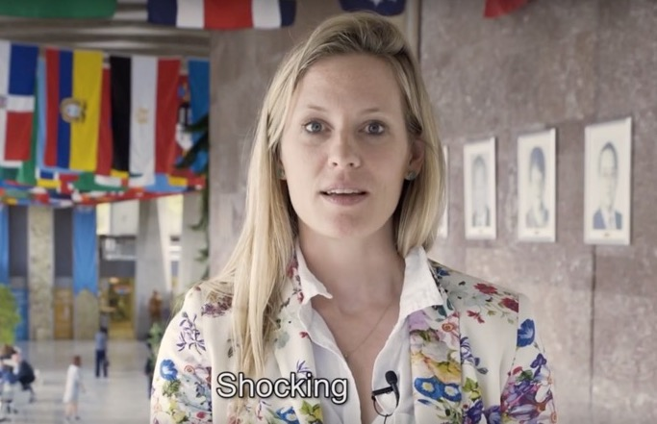

Message 4
@antonioguterres Secretary-General of @UN urges us all to support the urgent need for action on #WASH in #healthcare if we are to move from #WHA72 Resolution to the needed revolution #R2RWASHinHCF https://www.youtube.com/watch?v=Su53NTLFkdA&feature=youtu.be
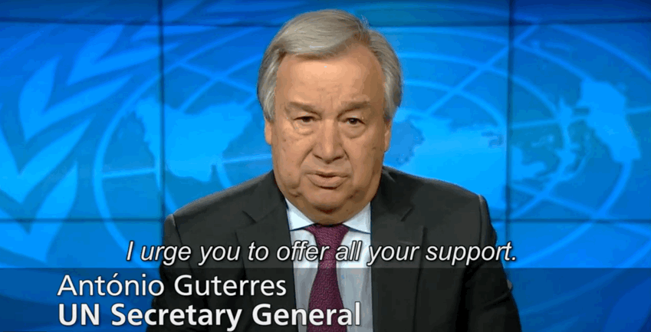

Message 5
If you find it frustrating that we’re still talking about #WASH in #healthcare join us to turn this year’s #WHA72 Resolution into a global revolution to save the lives of the most vulnerable #R2RWASHinHCF – make your commitment now #patientsafety

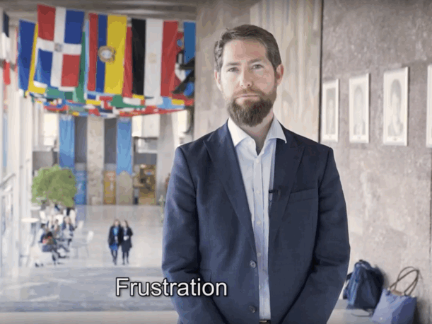

Message 6
From resolution to revolution – the change in #WASH in #healthcare facilities starts with you #R2RWASHinHCF https://www.washinhcf.org/latest_news/from-resolution-to-revolution-the-change-in-wash-in-health-care-facilities-starts-with-you/

Message 7
‘dignity’ ‘a fundamental human right’ ‘leave no one behind’ ‘hope’ ‘life’ What word summarises your feelings on the urgent need to act? #WASH in #healthcare #healthforall #R2RWASHinHCF https://www.youtube.com/watch?v=Su53NTLFkdA&feature=youtu.be
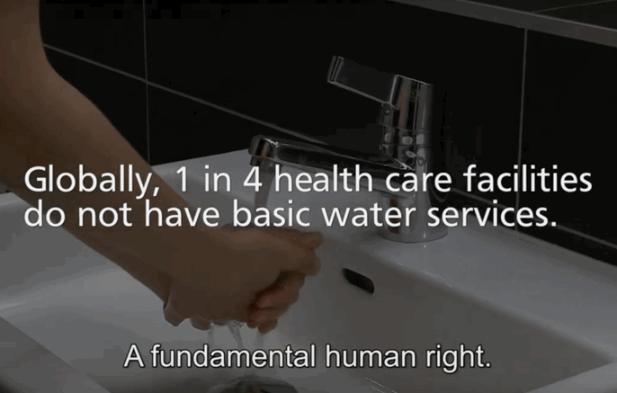

Message 8
The #WASH data truly is shocking: 1 in 5 #healthcare facilities have no sanitation services, 2 in 5 no #handhygiene at the point of care. Time for a revolution #R2RWASHinHCF #infectionprevention
https://www.washinhcf.org/wp-content/uploads/2019/04/9789241515504-eng.pdf
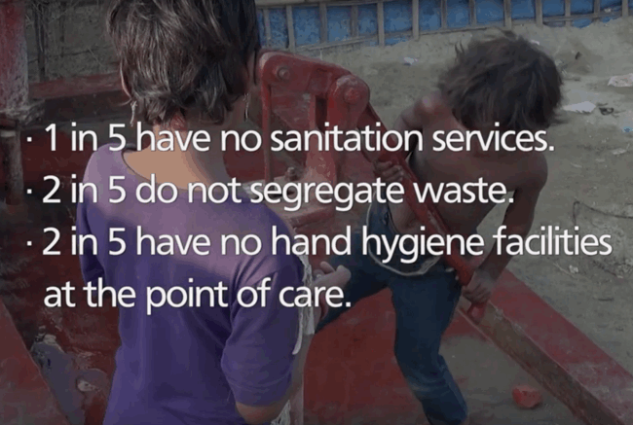

Message 9
“It has to be dignity” - what word summarises your feelings on the urgent need to act on #WASH in #healthcare #R2RWASHinHCF https://www.youtube.com/watch?v=Su53NTLFkdA&feature=youtu.be

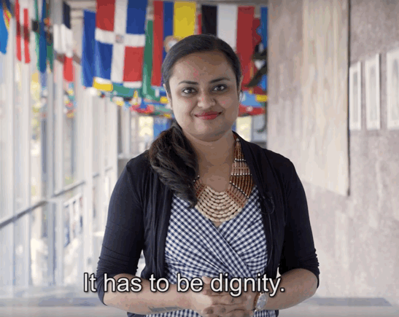

Message 10
“If you cannot ensure a good quality of care at the #healthcare facility – where else” we agree with @DrMariaNeira & that’s why we must seize this chance to move from #WHA72 Resolution to revolution #R2RWASHinHCF #WASHinHCF https://www.youtube.com/watch?v=Su53NTLFkdA&feature=youtu.be

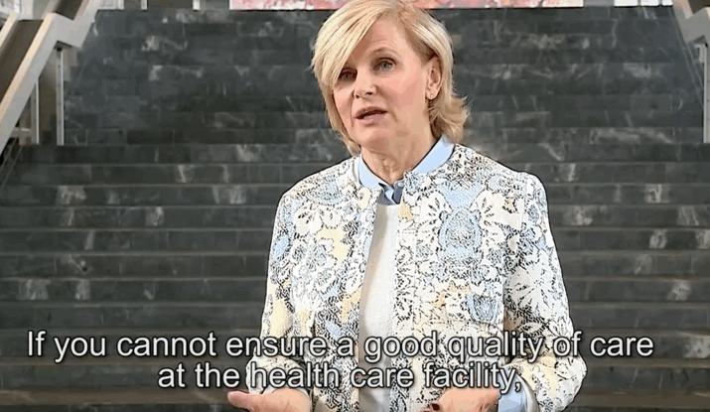

Message 11
We have a moment, a window to capitalise on this #WHA72 Resolution – every Member State agreed this year to make the step change needed on #WASH in #healthcare #R2RWASHinHCF https://www.youtube.com/watch?v=Su53NTLFkdA&feature=youtu.be #quality #healthforall #MCH
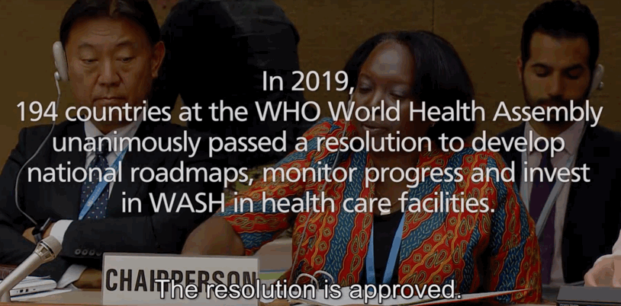

Message 12
#compassion & #WASHinHCF support quality #healthcare #R2RWASHinHCF https://www.youtube.com/watch?v=Su53NTLFkdA&feature=youtu.be

Message 13
#WASH in #healthcare is a social justice issue for populations across the world – we agree @shams_syed #quality #heatlhforall #R2RWASHinHCF https://www.youtube.com/watch?v=Su53NTLFkdA&feature=youtu.be

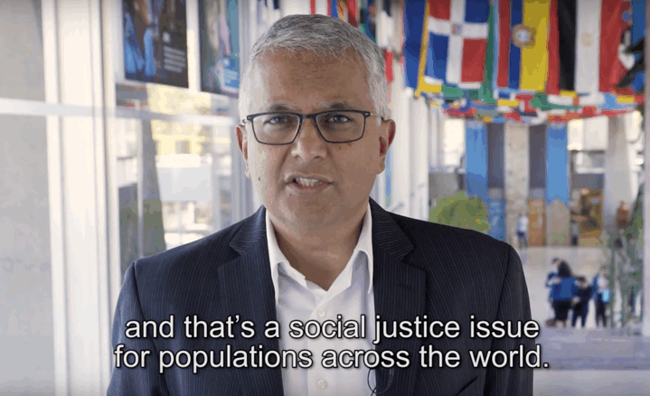

Message 14
#WASHinHCF from Resolution to Revolution the time is now #R2RWASHinHCF Stop avoidable #infection #antibioiticresistance https://www.youtube.com/watch?v=Su53NTLFkdA&feature=youtu.be

Message 15
#Quality #UHC is predicated on people & communities accessing promotive #healthcare. The shocking state of #WASHinHCF prevents this & puts millions at risk of deadly disease. Let’s work together to end this injustice #R2RWASHinHCF

Message 16
Imagine going into a hospital where there is no toilet. Imagine being a health worker there. It’s not acceptable in any country. It’s a matter of dignity. Important now to move from #WHA72 Resolution to revolution #R2RWASHinHCF #WASH in #Healthcare #healthworkforce

Web links to use:
- The resolution to revolution WHO video: https://www.youtube.com/watch?v=Su53NTLFkdA&feature=youtu.be
- The WASH in HCF portal – home page: https://www.washinhcf.org/
- The WASH in HCF portal – commitments: https://www.washinhcf.org/commitments/
- The WASH in HCF portal – resources: https://www.washinhcf.org/resources/
- The WASH in HCF portal – news: https://www.washinhcf.org/news/
- The JMP report: https://www.washinhcf.org/wp-content/uploads/2019/04/9789241515504-eng.pdf
- The Practical steps report: https://www.washinhcf.org/wp-content/uploads/2019/04/2019_WASH-in-HCF-Practical-Solutions-for-Universal-Access-to-Quality-Care_2April-compressed.pdf

At mentions:
The following entities and individuals (not exhaustive) may be at mentioned and tagged as appropriate in your tweets:

@WASH_FOR_HEALTH
@WHO
@GW2020
@GlobalHealthOrg
@WinHCFaction
@UN_Water
@UNICEF
@Wateraid
@DrTedros
@DrMariaNeira
@NeelamDhingra1 (tweets on patient safety)
@HananBalkhy (tweets on AMR & IPC) (can’t be tagged)
@WellbeingAfrica
@UNICEFWater
@DidierPittet (tweets on IPC)
@USAIDWater
@USAIDGH
@ABanerjeeWHO (tweets on maternal and child health)
@Shams_Syed (tweets on quality and UHC)
@NordstrmAnders
@SanWatforAll
@PMNCH (maternal and child health)

