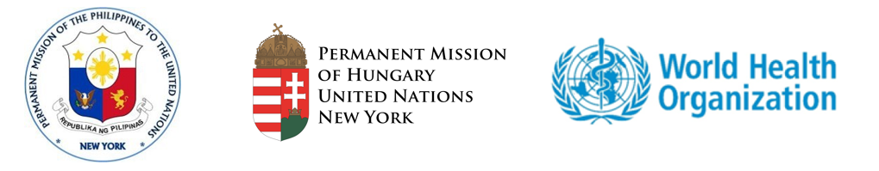

Group of Friends in Support of Water, Sanitation and Hygiene in Healthcare Facilities
Virtual Side Event on the Margins of the 55th Session of the
Commission on Population and Development

“Economic Benefits of Investing in Water, Sanitation and Hygiene in Healthcare Facilities”
28 April 2022, 1:30 PM – 2:45 PM (EDT)
Organizers: Permanent Missions of The Philippines and Hungary, WHO, and UNICEF
Health and wellbeing of many populations throughout the world are seriously jeopardized by the crisis of inadequate water, sanitation, and hygiene (WASH) in hospitals, health clinics and birthing facilities. The lack of these essential health services impacts nearly 2 billion people, notably women and children.

Experience with Ebola and COVID-19 has illustrated that hospitals without reliable, meaningful WASH services are breeding grounds for infectious disease and a threat to human health in the community and beyond. Weak, poorly functioning WASH and infection prevention and control programmes result in a vicious cycle of widespread infection, antibiotic use and misuse and spread of antimicrobial resistance (AMR) which is estimated to result in 25% increase in health expenditure in low-income countries by 2050.
WASH services are critical in the prevention of child and maternal mortality, an important component of the ICPD Programme of Action. The ICPD PoA recognizes the linkages between high levels of maternal mortality and poverty and that the reduction of maternal mortality and morbidity is a public health priority. The 2020 Global WASH Report also states that WASH in healthcare is a top priority of women receiving maternal care. Infections associated with unclean births account for 26% of neonatal deaths and 11% of maternal mortality; together these account for more than 1 million deaths each year.
There is also increasing global attention given to improving quality of care, as access to services alone has failed to reduce mortality and morbidity. Improving the quality of care for women and children, particularly mothers and newborn, is a critical step toward ending preventable maternal and newborn mortality and still-births and achieving the health-related SDGs.
The lack of funding for WASH in healthcare facilities undermines sustainable services. More support is needed at the country level to assist in understanding costs, budgeting opportunities and viable financing mechanisms. The total global economic losses associated with inadequate water supply and sanitation are estimated at US$ 260 billion annually, or 1.5% of GDP.

Investing in WASH and energy services in health care facilities is one of the core prescriptions for a healthy, green recovery from the COVID-19 pandemic. It is also a “best buy” from stopping the spread of infections (especially bacterial and viral) and ensuring healthy outcomes for new mothers and babies.

WASH is a global public good and the economic benefits considerably outweigh the costs.
It would take one year for investment in WASH to pay for itself and produce savings for every dollar invested thereafter. Yet, only 11% of countries indicate sufficient resources to reach national targets for WASH in health care facilities.

This event will aim to:

- Explore ways to implement costed national roadmaps for WASH in healthcare facilities with appropriate multi-sector financing, lead by governments and supported by development banks and donors, philanthropic agencies, nongovernmental organizations and the private sector, which will need to play a range of critical and catalytic roles.
- Discuss country practices and good examples to integrate WASH into regular health sector planning, budgeting and programming to ensure access, deliver quality services and improve on existing WASH services, including COVID-19 response and recovery efforts, particularly for women and children.
- Share expertise on economic losses and gains, as well as budgeting opportunities and financing mechanisms associated with WASH in healthcare facilities.
13:30 – 13:35  13:35 – 13:40  13:40 – 13:45 | Opening  H.E. Ms. Zsuzsanna Horváth, Permanent Representative of Hungary to the UN  Keynote Address  H.E. Mr. Karl Kendrick Chua, Secretary for National Economic and Development Authority, Philippines  Dr. Maria Neira, Director of Environment, Climate Change and Health, WHO
13:45 – 13:47  13:47 – 14:25 | Moderator  Werner Obermeyer, Director of the WHO Office to the UN  Panel Discussion  Country examples of implementing costed national roadmaps for WASH in HCF  - Ghana: Dr. (Mrs.) Mary Eyram Ashinyo, Deputy Director, Institutional Care Division, Ghana Health Service  Examples to integrate WASH into regular health sector planning, budgeting, and programming. Budgeting opportunities and multi-sector financing mechanisms.  - World Bank: Ms. Claire Chase, Senior Economist in the World Bank’s Water Global Practice in the East and Southern Africa region  - Sanitation and Hygiene Fund: Mr. Dominic O’Neill, Executive Director  - UNICEF: Ms. Kelly Ann Naylor, Director, Water, Sanitation, Hygiene (WASH) & Climate, Environment, Energy, and Disaster Risk Reduction (CEED) Programme Group  - World Vision: Mr. Paul Oyesigye, Program Manager, World Vision Uganda
14:25 – 14:40 | Q&A
14:40 – 14:45 | Closing  H.E. Mr. Enrique Austria Manalo, Permanent Representative of the Philippines to the UN
PROGRAMME

